## ­PROPOSAL

**A Chinese Speech Recognition Application for Children Enhancement in Speaking**



**By**

1. Lukita Iswara 160919005

**Information Technology Program**

**University of Surabaya Engineering Department**

**2022**

1. **Introduction**

The Chinese language is known as the most complex language globally in today's world. Mainly the Chinese had five tones for distinguishing different characters:

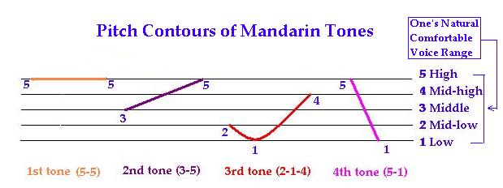

Figure 1: shows five types of Chinese styles.

This image is copyrighted from web.mit.edu.

It is not easy for a machine to process Chinese sounds since a single word can mean different meanings. For instance, if a speaker says mā, its means mother, but if the speaker says mǎ, its means horse. The computer may have difficulty recognizing this word as a different word. Moreover, we are targeting this voice recognition to children to understand mandarin. Children have a short vocal cord which is different from an adult which has a heavier voice. Most Chinese voice recognition today is targeted at adults than children. This let some misunderstandings among children about the right way to speak Chinese. Sometimes the voice recognizer cannot recognize the children voice

This paper will help children speak Chinese better by using voice recognition. The voice recognition will be integrated with Convolutional Neural Network (CNN). CNN is a deep learning algorithm used to differentiate images from one another. We plan to use CNN since it is the best algorithm for recognizing images. The picture we will be using is Mel-frequency cepstral coefficients (MFCCs). MFCCs are the coefficient of the power spectrum in a sound. Most voice recognizers use MFCCs’ raw data for them to see sound.

The main interface used for human interaction is the smartphone application. We will use a smartphone because it has been common in our society now. In the interface, children will choose the character they want to learn. When the surface is clicked, the software will demonstrate nature to the user. The children then need to say the word while the voice recognizer checks if the child tells the correct words.

The dataset is obtained manually without the use of any existing datasets. The programming language that is going to be used is Python and Kotlin. The sound model will be loaded by using the Librosa library and executed by the use of the Keras library.

1. **Research Question**

From the above exploration, this research. The research question will focus on this central area:

* How to enhance children’s education in Mandarin Chinese language-speaking?
* How to make children differentiate Chinese Mandarin intonation?
* How to teach children to speak Chinese Mandarin?

1. **Research Objective**

Developed voice recognition software to help children speak the Chinese Mandarin language.

1. **Implication**

Implication for children in elementary school

* Quick character recognition
* Increase the speaking fluency
* Better memorization